Campus Portal Mini-System

Spring Boot IoC & DI with React Frontend
Student Name: Saad Mughal
Student ID: F2023-009
Course: Web Engineering
Instructor: Sir Nouman Ali
Submission Date: November 10, 2025

1. Project Overview
This assignment demonstrates the implementation of a Campus Portal system using Spring Boot's Inversion of Control (IoC) and Dependency Injection (DI) principles, integrated with a React frontend. The project showcases loosely coupled architecture, layered design patterns, and full-stack integration.

Technologies Used
Backend Framework | Spring Boot 3.5.7
Java Version | Oracle JDK 17
Build Tool | Maven
Database | MySQL 8.x
Frontend Framework | React 18
UI Library | Bootstrap 5 (React-Bootstrap)
Development IDE | IntelliJ IDEA & WebStorm
API Testing | Postman

2. Dependency Injection Types Implementation

2.1 Field Injection
Field injection uses the @Autowired annotation directly on class fields. Spring injects dependencies after object instantiation.
Advantages: Concise syntax, less boilerplate code.
Disadvantages: Cannot create immutable fields, harder to test, hides dependencies.

2.2 Constructor Injection
Constructor injection passes dependencies as constructor parameters. This is the recommended approach in Spring.
Advantages: Enables immutability, easier unit testing, explicit dependency declaration, mandatory dependencies enforced at compile time.
Disadvantages: More verbose for multiple dependencies.

2.3 Setter Injection
Setter injection uses @Autowired on setter methods to inject dependencies after object creation.
Advantages: Allows optional dependencies, enables re-configuration after instantiation.
Disadvantages: Mutable dependencies, less explicit than constructor injection.

3. Task Implementation Details

Task 1: Basic Service Injection
Components:
- MessageService interface with getMessage() method
- StudentMessageService implementation returning "Welcome Student to Campus Portal"
- AdminMessageService implementation returning "Welcome Admin to Campus Portal"
- WelcomeController demonstrating all three injection types
Bean Selection: Used @Primary and @Qualifier annotations to control which bean gets injected.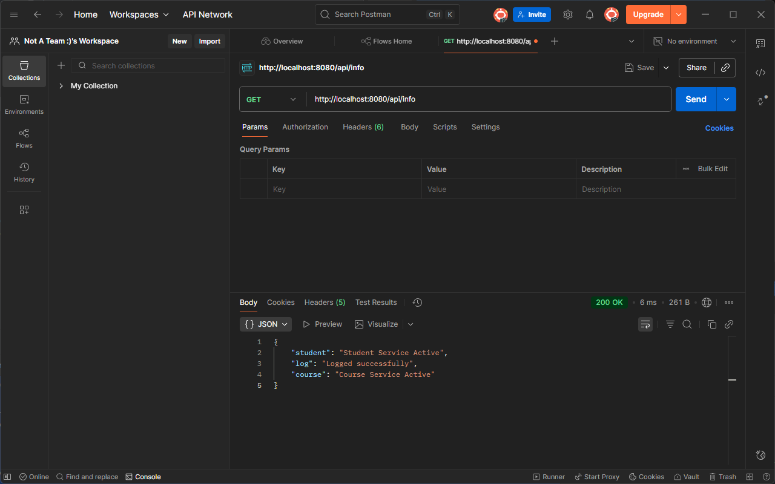
Screenshot: Task 1 POSTMAN test.

Task 2: Layered Architecture with DI
Architecture:
- LoggerService: Common logging service with log(String message) method
- StudentService: Handles student-related operations, depends on LoggerService
- CourseService: Handles course-related operations, depends on LoggerService
- InfoController: REST controller exposing /api/info endpoint
Response Format: JSON with student, course, and log status information.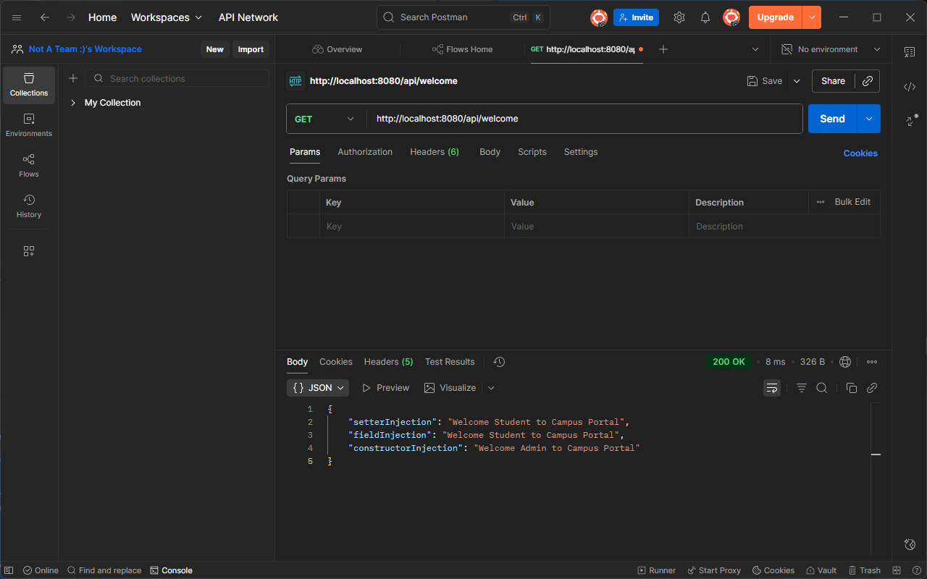
Screenshot: screenshot-task2-postman-api-info.png

Task 3: React Frontend Integration
Implementation:
- React component fetches data from /api/info endpoint on mount
- Displays JSON response in styled Bootstrap grid
- Includes "Refresh Info" button to re-fetch data
- Uses React hooks (useState, useEffect) for state management
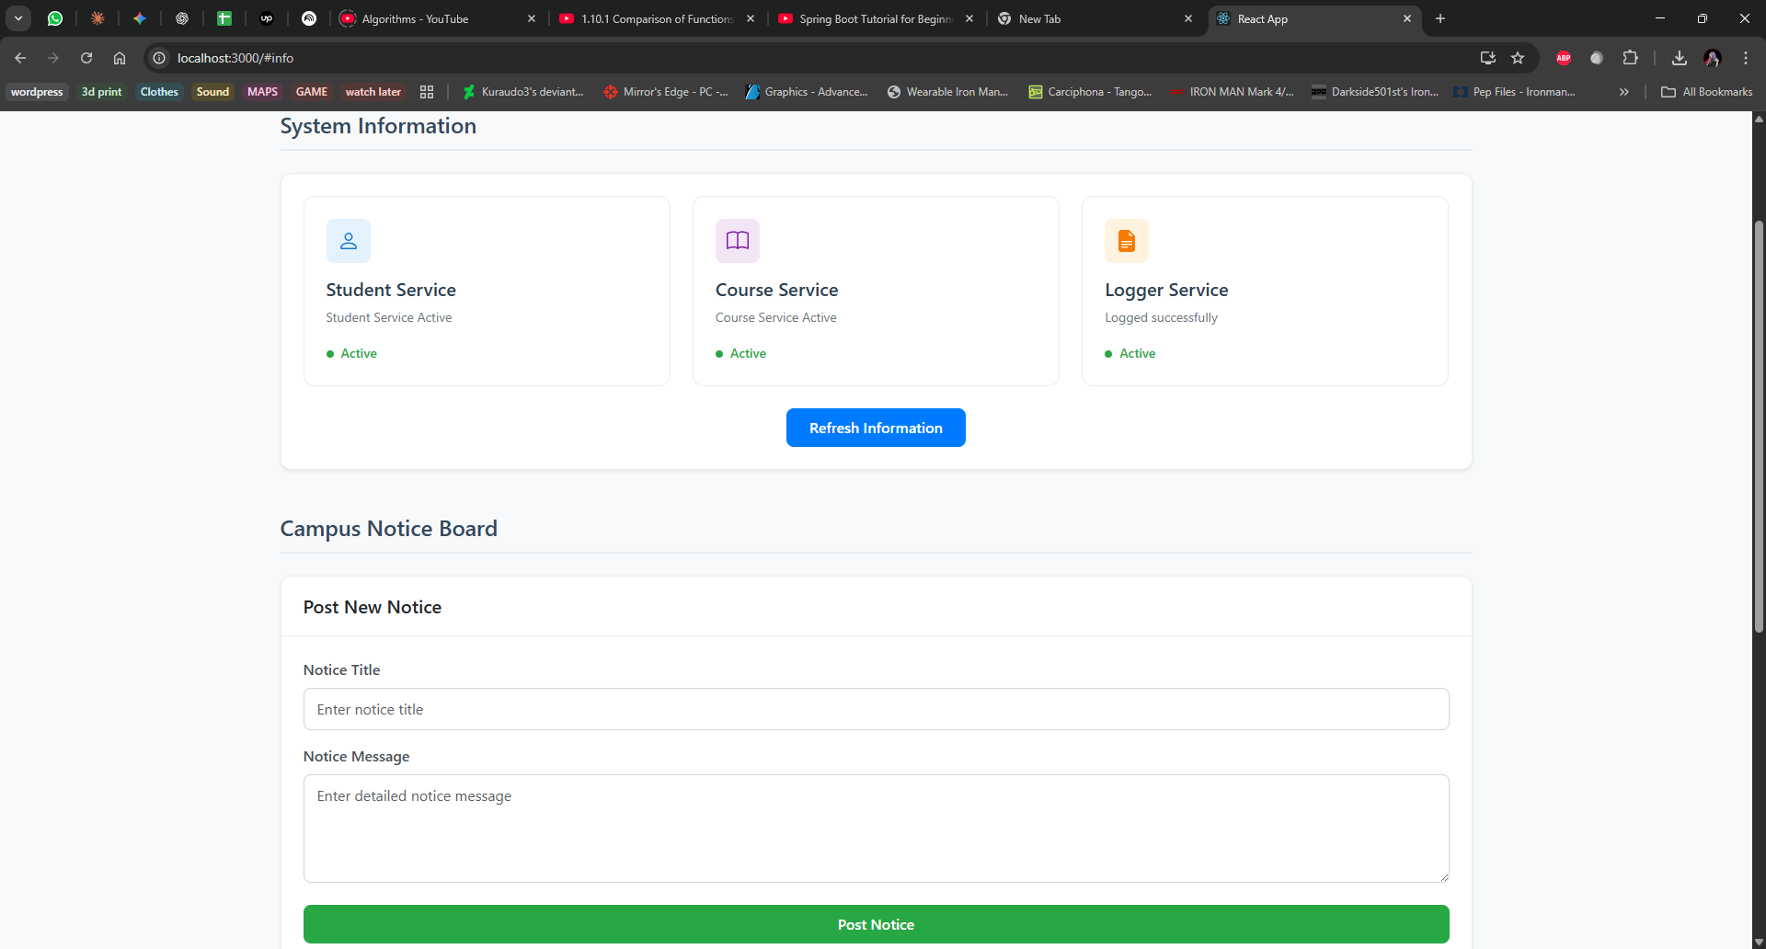
Screenshot: screenshot-task3-react-info-display.png

Task 4: Profile-Based Bean Injection
Components:
- DatabaseConfig interface
- MySQLDatabaseConfig: Active in dev profile (@Profile("dev"))
- PostgreDatabaseConfig: Active in prod profile (@Profile("prod"))
- /api/dbinfo endpoint showing active database configuration
Configuration: Uses separate application-dev.properties and application-prod.properties files.

Task 5: Campus Notification System
Backend Components:
- Notice entity with id, title, message, and timestamp fields
- NoticeRepository: JPA repository for database operations
- NotificationService: Business logic for notice management
- NotificationController: REST endpoints for notice operations
API Endpoints:
- POST /api/notice: Create new notice (request body: title, message)
- GET /api/notice: Retrieve all notices
Frontend Components:
- NoticeBoard component displaying all notices in Bootstrap cards
- Form with title and message inputs for creating new notices
- Real-time state update and re-rendering on form submission
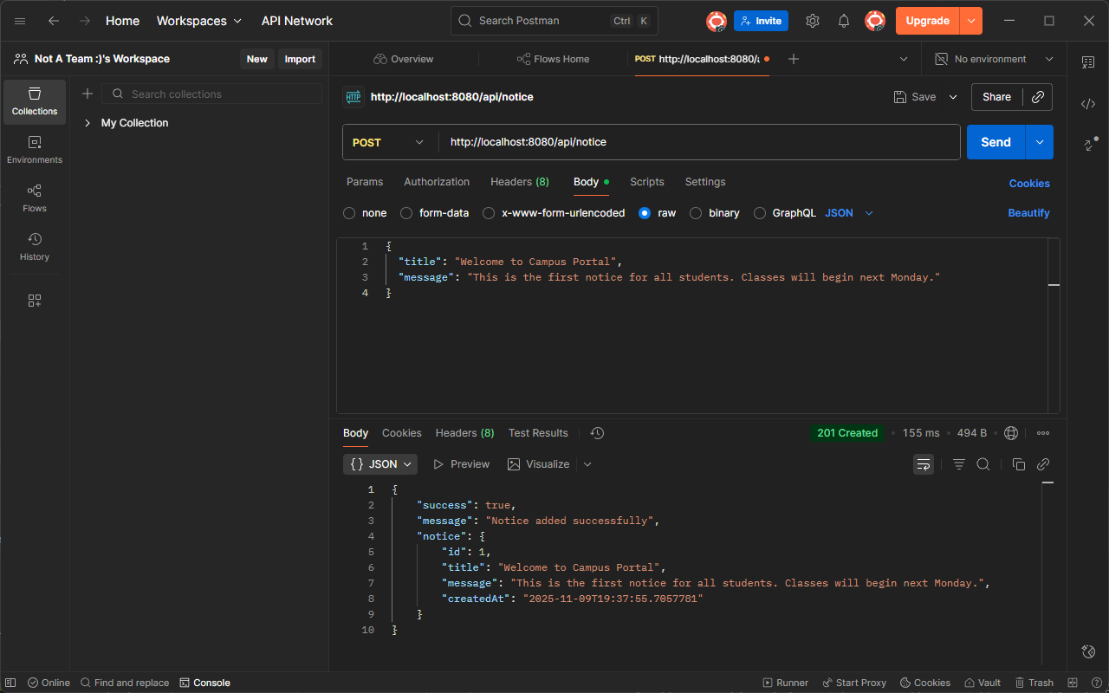
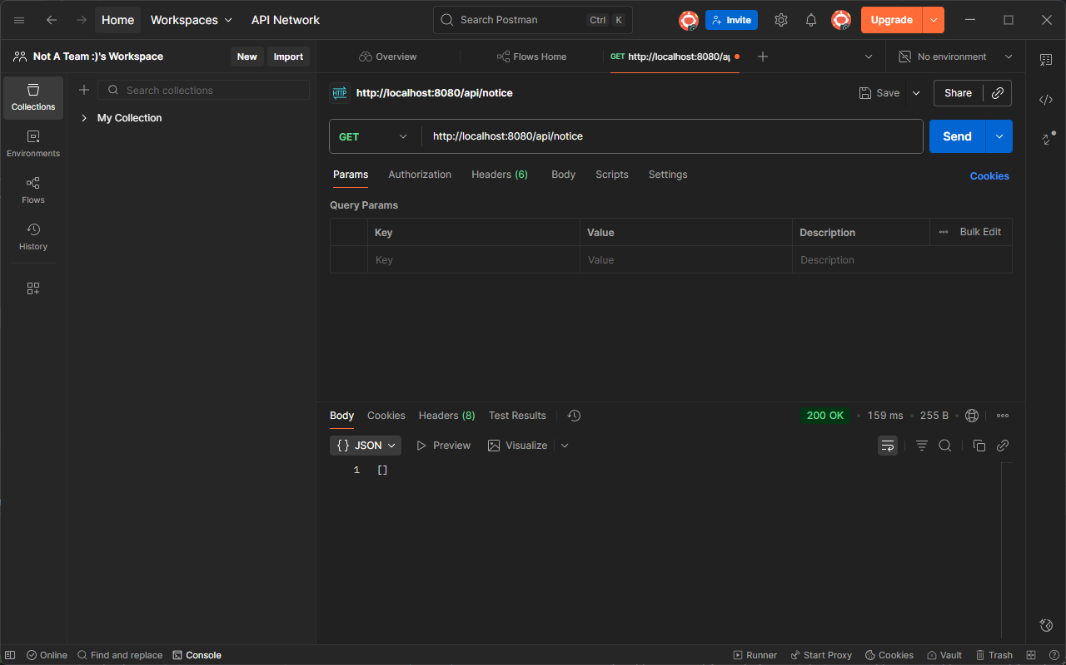
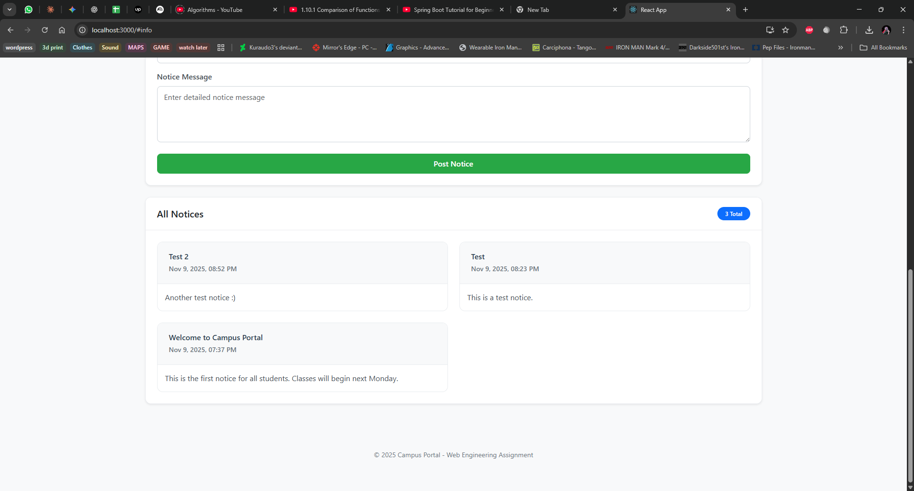
Screenshot: screenshot-task5-postman-post-notice.png
Screenshot: screenshot-task5-postman-get-notice.png
Screenshot: screenshot-task5-react-noticeboard.png

4. Class Relationships and Dependencies

Task 1 Relationships
- WelcomeController depends on MessageService interface
- StudentMessageService implements MessageService
- AdminMessageService implements MessageService
- Controller uses different injection methods for demonstration purposes

Task 2 Relationships
- StudentService depends on LoggerService
- CourseService depends on LoggerService
- InfoController depends on both StudentService and CourseService
- Demonstrates loose coupling through shared service dependency

Task 5 Relationships
- NotificationController depends on NotificationService
- NotificationService depends on NoticeRepository
- NoticeRepository extends JpaRepository for database operations
- Follows standard three-layer architecture: Controller → Service → Repository
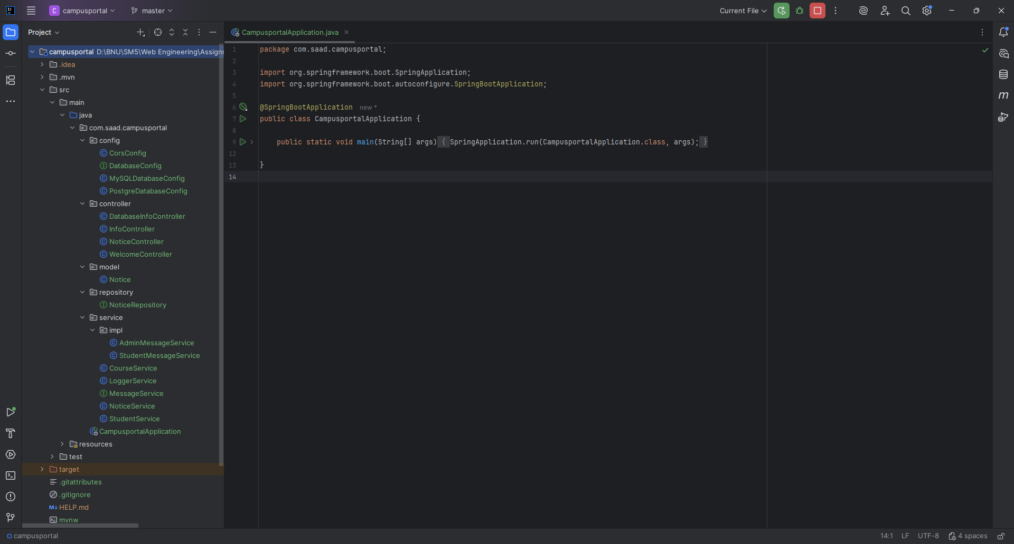
Screenshot: screenshot-project-structure.png

5. Database Configuration
Database: MySQL (campus_portal_db)
JPA Configuration: Hibernate auto-DDL enabled for automatic schema generation
Connection Details: Configured in application.properties with MySQL JDBC driver
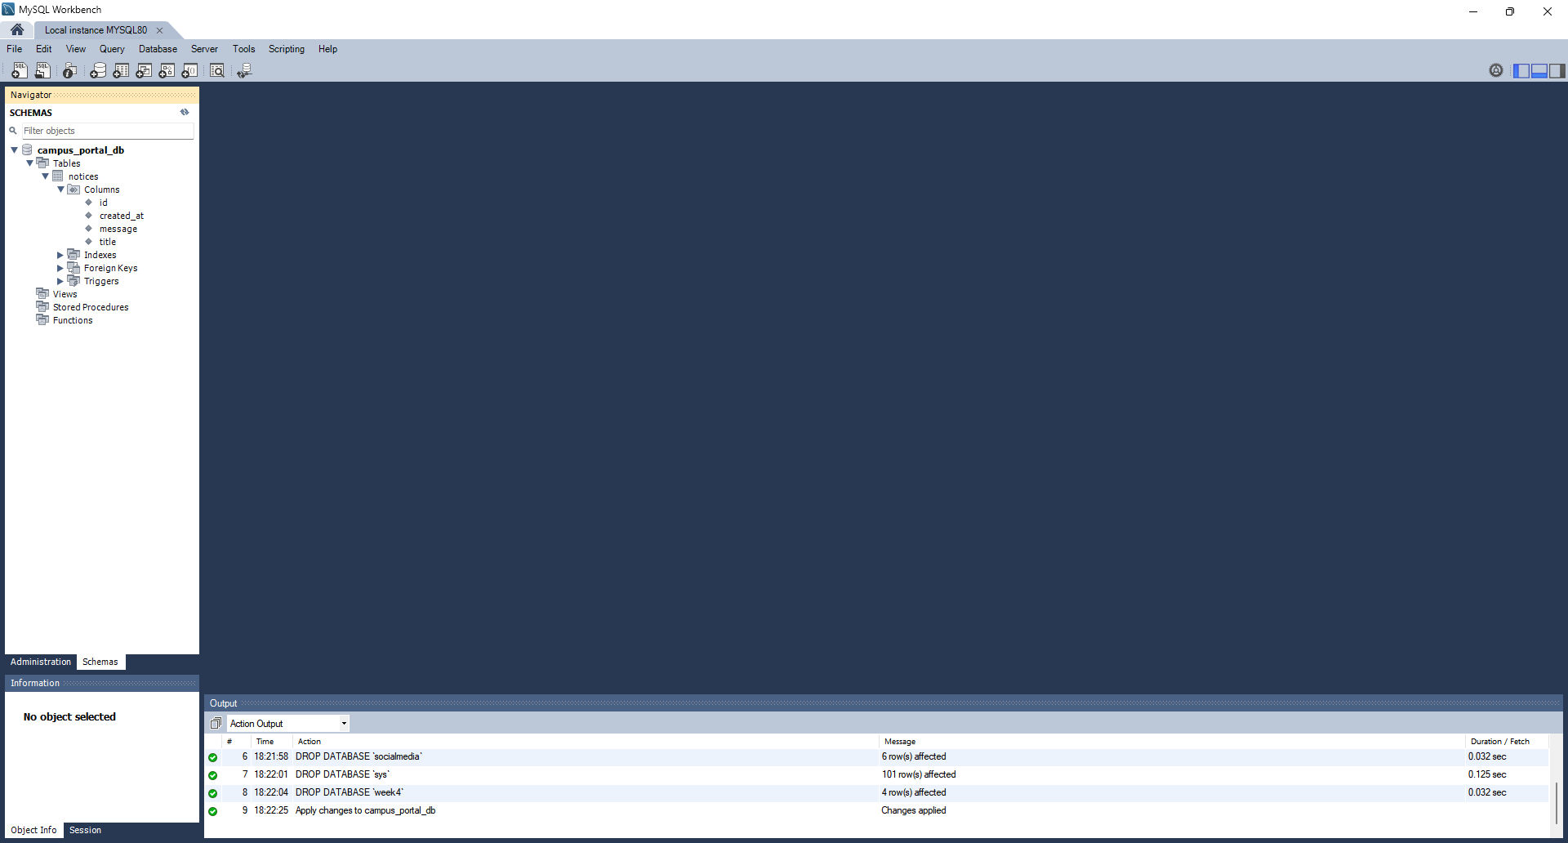
Screenshot: screenshot-mysql-notices-table.png

6. Testing and Validation
All API endpoints were tested using Postman to ensure proper functionality:
- GET requests verified correct data retrieval
- POST requests validated data persistence to database
- Profile-based configuration tested by switching active profiles
- Frontend-backend integration tested through browser

7. Key Learning Outcomes
- Understanding of Spring's IoC container and how it manages bean lifecycle
- Practical implementation of different dependency injection types and their use cases
- Building loosely coupled, maintainable code through interface-based design
- Implementing layered architecture with proper separation of concerns
- Profile-based configuration for environment-specific bean activation
- Full-stack integration between Spring Boot REST APIs and React frontend
- Using Spring Data JPA for database operations with minimal boilerplate

8. Future Enhancements
- Implement Spring Security for authentication and authorization
- Add JWT-based token authentication for API endpoints
- Restrict POST /api/notice endpoint to admin users only
- Add input validation and error handling
- Implement pagination for notice listing
- Add edit and delete functionality for notices

9. Conclusion
This assignment successfully demonstrates the core concepts of Spring Boot's Inversion of Control and Dependency Injection principles. The implementation showcases how loosely coupled components can be wired together using Spring's IoC container, creating a maintainable and scalable application architecture. The integration with React frontend demonstrates practical full-stack development skills and the ability to build complete web applications.

